**LAB CYCLE 4**

# QUESTION SET 6 date:08-08-2021

Consider the database for a banking enterprise. Write the queries for the below questions.

1. Create the following tables

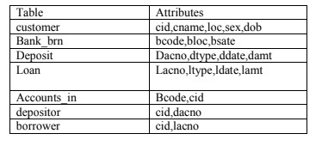

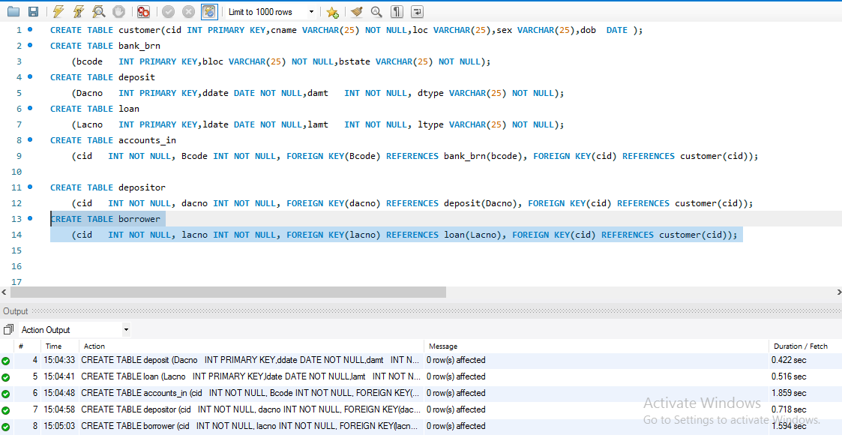Output

1. Include necessary constraints.

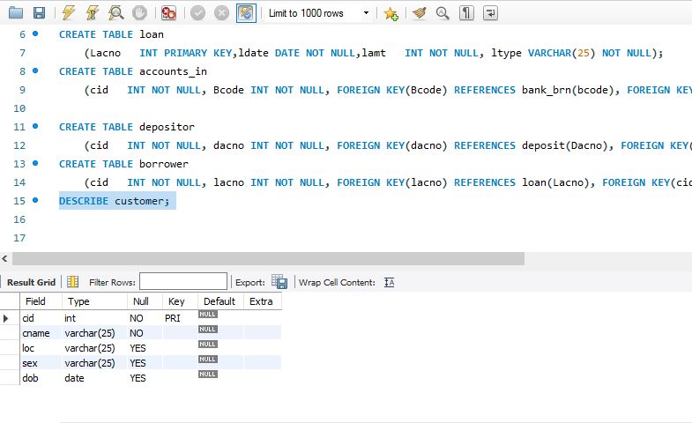Output

(iii)Tables are created under the database ‘bank’

output

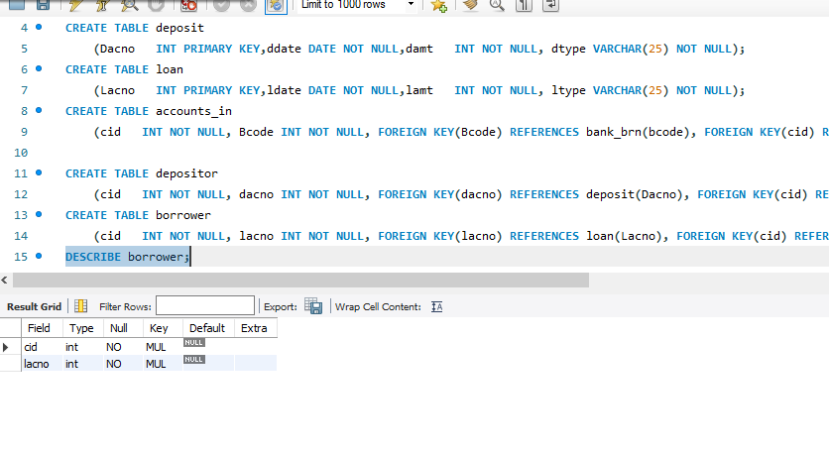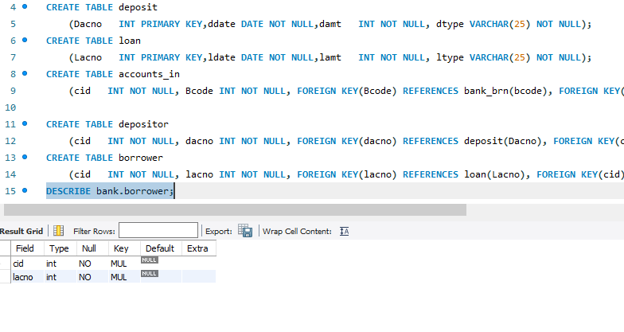

1. Display all the tables in bank database

Output

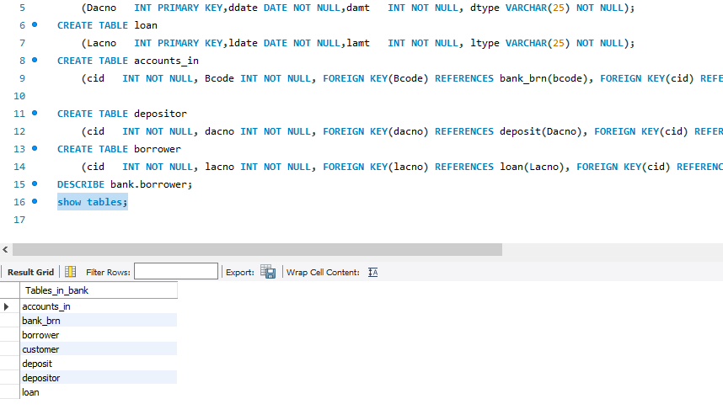

1. Describe the structure of all tables

Output

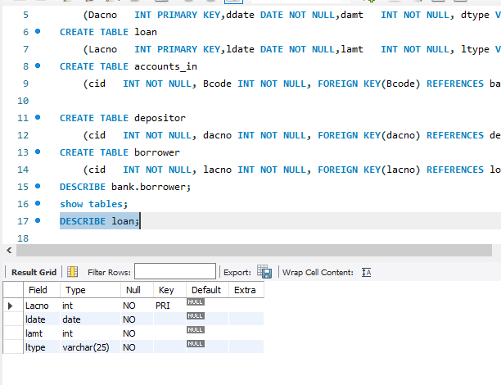

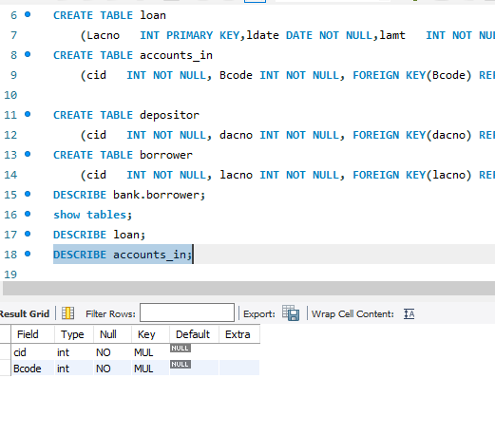

(vi) Delete tables.

Output

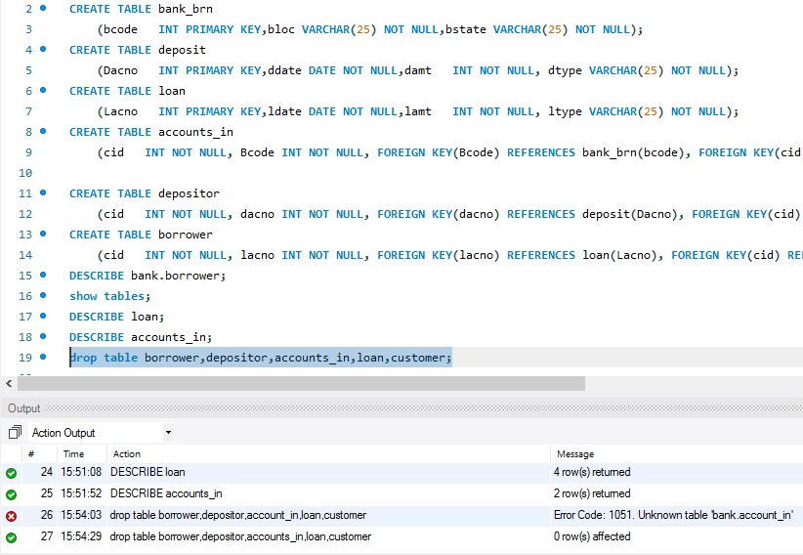

# Q.SET 8

Consider the following database for a banking enterprise.

* BRANCH (bid:int, branch-name: String, branch-city: String, assets: int)
* ACCOUNTS (accno: int, bid:int, balance: int)
* DEPOSITOR (cid:int, accno: int)
* CUSTOMER(cid:int,

customer-name:String,customer-street:String,customer-city: String)

Set primary key and foreign keys and insert valid records based on questions.

Write SQL queries to

1. Find all the customers who have at least two accounts at the Mainbranch.

Output

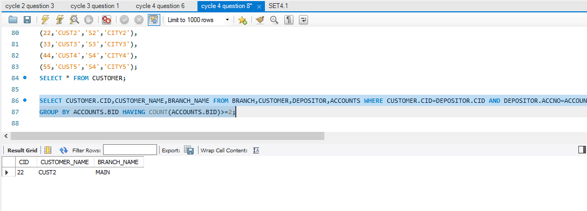

1. Find all the customers who have an account at all the branches located in a specific city.

Output

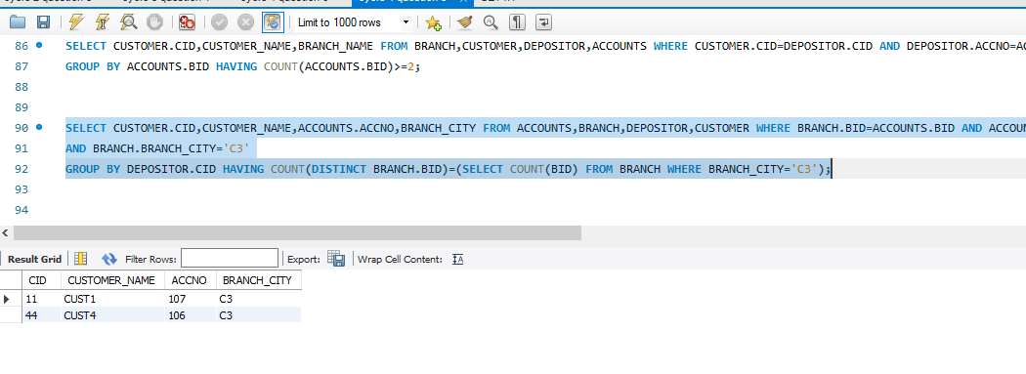

1. Find the branch with greatest asset.

Output

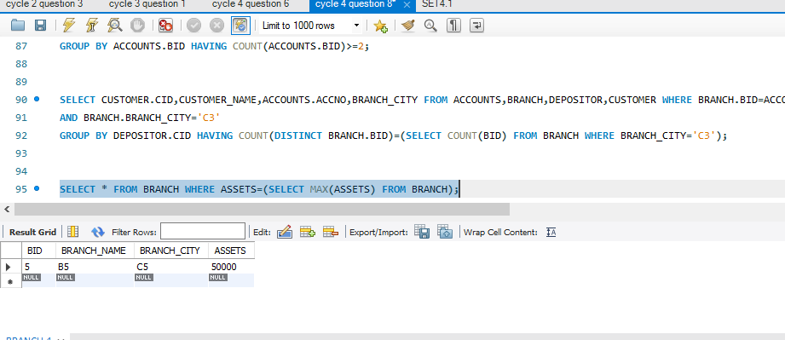

1. Find the customer with highest balance.

Output

